Style Guide for Paper Submissions to the 6th Doctoral Design Conference
DDC ’19 : TransFormation

INTRODUCTION
This document describes the format of research papers submitted to the 6th Doctoral Design Conference (DDC ’19 : TransFormation) organised by UNIDCOM/IADE in Lisbon on the 22-24th May 2019. The conference has the theme of
At the end of the document is a template paper which you should use as a structure for your own paper.
SUBMISSION RULES
- Submission deadline
7th April 2019 at 11.59pm Western European Standard Time
- Length
Papers have a fixed page limit of 8 pages including bibliography, figures, tables and appendices, formatted according to this template.
- File format
You must submit your paper electronically in MS Word document format (with the extensions .doc or .docx)
- File name
The paper must be named in the format: AuthorLastName_FirstName_PaperTitle.doc
- Language
We only accept contributions written in English. In case of acceptance, the Oral Presentation should also be made in English.
- Eligibility for submission
We invite PhD students to submit research papers on the theme of transformation within the following categories:
- Interaction Design and User-centered Design
- Design for Social Innovation and Sustainability
- Design Principles and Practices
- Envisioning Futures
- Mapping Design
- Art and Visual Production
- Communication, Culture, and Consumption
The papers must not have been previously presented at a conference or published elsewhere.
- Anonymous submission
All proposals undergo double-blind review. Therefore, DO NOT include author or institutional information in the initial proposals. If your proposal is accepted, you will be instructed to add authors’ names and affiliations in the final draft for publication in the proceedings.
- Where to submit
Your paper must be submitted to the EASYCHAIR Conference system: https://easychair.org/conferences/?conf=ddc19
- After acceptance
If your proposal is accepted, you will have an opportunity to update it for publication in the conference proceedings.
CONTENT
- Abstract
The abstract should provide a summary of the research paper, and should not exceed 200 words. This is the last part of the paper that you should write.
- Keywords
The abstract should be followed by no less than three but no more than five keywords.
- Introduction
You should provide a clear introduction to your research: you should include the background to your research, the questions that you set out to answer, and the rationale for carrying out the research.
- Main body sections
You may choose whichever body sections best suit the format of your research, but you may wish to include sections on background, a literature review, methodology, research carried out, results, interpretations, future work etc.
- Conclusion
You should end with a conclusion that provides a summing up and a reflection on the research covered in the paper.
- Acknowledgements
If there are acknowledgements, these should appear at the final, immediately before the references.
- References
- A bibliography should be placed at the end of the text, listed alphabetically by the surname of the first author.
- Do NOT number references.
- Hanging indentions are preferred, with no additional spacing between references.
- Citations in the text should contain the author's surname and year of publication in parentheses (e.g., Johnson, 2012).
- Use APA style, v.6., of referencing. For more information, consult the APA Publication Manual (6th edition).
- We recommend using reference management software for your references and bibliography, such as Zotero, Mendeley or EndNote.

Document structure
- Paper size
A4
- Margins
All margins = 2.54cm
- Page numbering
Do not number pages.
- Headers and footers
Do not add a header or alter the existing footer.
- Footnotes
Footnotes should be set using 10-point Arial left justified.
- Figures, images and tables
Figures, tables and images should be placed In Line With Text as close as possible to the text that references them. These elements should not appear without being referred to in the body text or without a caption. Whenever possible, these should be as wide as the text or appear centred, if narrower, without exceeding the document margins.
- Symbols and Abbreviations
Use only standard symbols and abbreviations. The use of SI (metric) units is required. Consult the APA Publication Manual (Tables 4.4 and 4.5).
- Captions
Captions should us Arial 10 point bold italic, and should be numbered (e.g: “Table 1“, “Figure 1”) and centred immediately below their corresponding image, table or figure.
- Equation Numbers
When numbering equations, enclose the numbers in parentheses and place them flush with the right margin. Here is an example:
2007 – 1957 = 50 (1)
- Multimedia attachments and appendices
We encourage authors to submit multimedia attachments using common formats (JPEG, MPEG, MP3 etc) to complement and enrich the textual submissions. For appendices larger than 10Mb, you should ask for the DDC’18 Organizing Committee agreement beforehand.
TEXT Formatting
- Typeface
Georgia
- Text Styles
The following text styles are predefined in this document, and should be used to format your paper:
 | Font size | Formatting | Line spacing | Space before | Space after
Title | 18 | Bold, Title Case, Centre aligned | Single | 10pt | 10pt
Subtitle | 16 | Italic, Title Case, Centre aligned | Single | 5pt | 10pt
Authors | 11 | Bold, Centre aligned | Single | 0pt | 0pt
Author affiliation | 11 | Italic, Centre aligned | Single | 0pt | 0pt
Section | 12 | Bold, All Caps, Left aligned | Single | 10pt | 5pt
Subsection | 11 | Bold, Title Case, Left aligned | Single | 10pt | 5pt
Body | 10.5 | None, Left aligned | Multiple at 1.25pt | 0pt | 5pt
References | 10.5 | None, Left aligned, Hanging indent of 0.5cm | Multiple at 1.25pt | 0pt | 5pt
Figure Title | 10 | Bold Italic, Centre aligned | Single | 0pt | 5pt
Figure Legend | 10 | Italic, Centre aligned | Single | 0pt | 10pt

Example paper
On the following pages is an example paper and template. Please use this template to duplicate the style of the paper, using the pre-set style formats on the Style menu, as the table above. You should simply delete the dummy text and replace it with your own content, matching all styles.

Title of Your Research Paper
Subtitle if Required
Author/s:
Adam Smithª
Elliot Chapman^{b}
ª Department of Industrial Design
IADE, Universidade Europeia, Laureate Universities, Lisbon, Portugal
smith.adam@universidadeeuropeia.pt

^{b} UNIDCOM/IADE
Lisbon, Portugal
chapman@gmail.com

ABSTRACT
Lorem ipsum dolor sit amet, consectetur adipiscing elit. Nunc vulputate ex ipsum, at sollicitudin nisi convallis nec. Aliquam erat volutpat. Integer fringilla tempor feugiat. Praesent gravida lectus et ipsum eleifend consectetur. Etiam rutrum, felis et scelerisque euismod, quam risus molestie arcu, a bibendum orci erat eu lacus. Aliquam eget mi faucibus, molestie metus sed, laoreet est. Ut pulvinar magna nulla, ut lacinia tellus rutrum eu.
Keywords: keyword1, keyword2, keyword3, keyword4, keyword5
INTRODUCTION
Phasellus ornare felis non tortor cursus, eu aliquet ipsum fringilla. Aenean porttitor metus quis urna molestie rhoncus. Praesent euismod eleifend erat quis viverra. Nulla cursus sollicitudin turpis sit amet mattis. Quisque orci mauris, ornare eu dictum et, varius nec risus. Vivamus at facilisis dui, faucibus tempus augue. Vivamus orci nibh, consectetur at euismod nec, sagittis consectetur mauris. Aenean quis quam pellentesque, convallis neque ac, sodales ante. Duis quis neque in nisi bibendum feugiat sed sit amet orci. Quisque pellentesque ultrices lacus a efficitur. Phasellus mauris sapien, consectetur condimentum lacus vel, tempor suscipit dolor. Integer fringilla nunc turpis, et volutpat enim dignissim vitae. Phasellus eget urna ut dolor lacinia imperdiet eget vel justo. Sed lobortis dignissim orci, vel tincidunt arcu.
Pellentesque vitae ipsum sapien. In convallis porta sem sit amet molestie. Suspendisse potenti. In ac malesuada nisl, eget blandit urna. Proin vehicula, felis in posuere faucibus, dolor nunc facilisis diam, sed aliquet turpis felis sed ligula. Pellentesque ac justo vitae augue mollis consequat.
MAIN BODY SECTIONS
Please add whichever main body sections and subsections are most appropriate for your paper.
Sed augue ligula, maximus ut rhoncus in, pharetra quis lorem. Sed nisl ex, bibendum a ultrices eget, imperdiet in felis. Nunc feugiat ultrices feugiat. Etiam gravida, ex ut porttitor varius, purus ipsum sagittis risus, vitae ornare magna ligula non ligula. Proin posuere sit amet turpis in suscipit. Cras tincidunt neque nec metus mattis dictum. Cras euismod efficitur accumsan. Aenean laoreet purus porta elit tincidunt, eget tincidunt leo aliquet. Praesent eu augue sit amet sem venenatis porta. Cras molestie ipsum in iaculis congue. Duis consectetur vulputate euismod. Donec pretium dignissim metus non lacinia. Vestibulum dolor dui, laoreet sed eros sed, consectetur convallis tortor.
Subsection 1
Lorem ipsum dolor sit amet, consectetur adipiscing elit. Proin in malesuada quam. Mauris in nunc odio. Donec et pharetra massa.
Aliquam luctus mauris vel velit vestibulum tincidunt. Maecenas sit amet diam in nulla vulputate iaculis in vel nisl. Vivamus venenatis elit sed tellus posuere, nec placerat elit facilisis. Praesent auctor augue non felis hendrerit, at elementum metus posuere. Ut ligula leo, vulputate eget feugiat sed, convallis a purus.
Subsection 2
Vestibulum ultricies erat id dapibus elementum. Suspendisse ante purus, consequat gravida elit quis, pretium fermentum mauris. Ut at venenatis sem. Duis purus orci, euismod sit amet luctus non, vulputate quis turpis. Quisque id dictum eros.
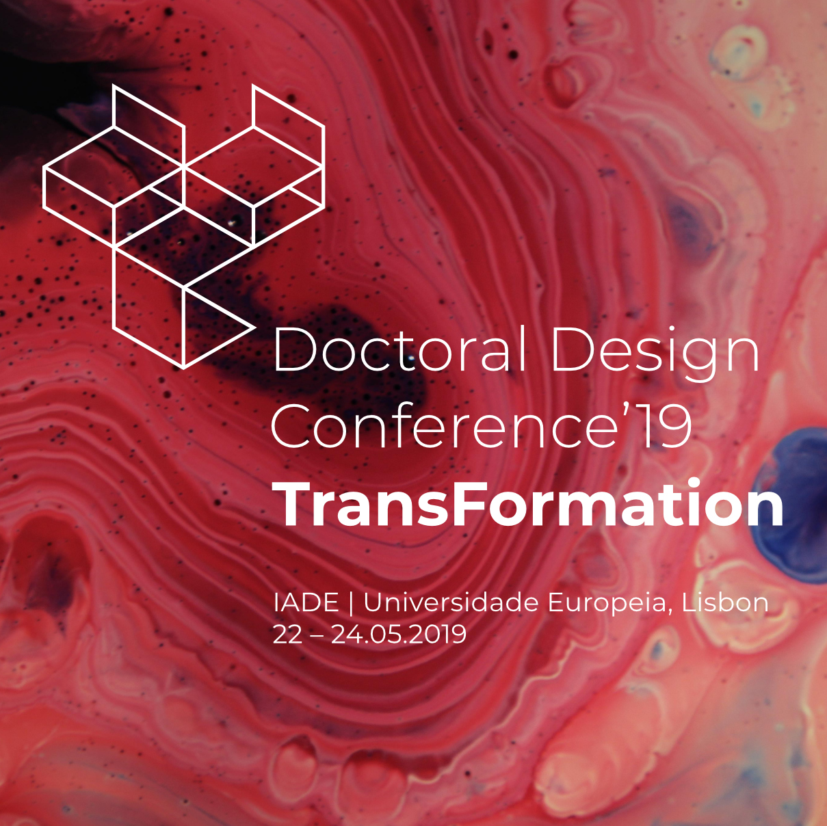
Figure Title
Figure Legend
Nunc non tellus et lectus malesuada iaculis. Duis ac lacinia arcu, non tincidunt felis. Class aptent taciti sociosqu ad litora torquent per conubia nostra, per inceptos himenaeos. Vivamus a risus dolor. Cras quis faucibus turpis. Quisque ex nibh, accumsan cursus nunc id, scelerisque porttitor augue. Ut rhoncus, metus at luctus auctor, orci eros ultrices arcu, et vehicula purus ligula ac tortor. Nunc non metus nec diam tempus porttitor ut sit amet sapien. Curabitur consectetur nunc ut lorem dapibus, nec congue erat ultricies. Nunc tempus, orci eget tempus ultrices, felis eros elementum dui, sed gravida dui orci eget est.
CONCLUSION
Phasellus auctor hendrerit elit ut sodales. Donec leo velit, finibus ac sodales molestie, pretium id nulla. Cras tempus, velit eget porta porttitor, ante erat cursus nisi, nec lacinia orci risus nec libero. Vivamus nec dolor tortor. Integer volutpat nisi non sodales placerat. Curabitur mollis elit non libero feugiat, sed blandit ipsum ultricies. Curabitur ac placerat lectus, ut egestas augue. Etiam eget dolor quis purus aliquam volutpat a at metus. Integer ullamcorper tincidunt tristique. In a eros euismod, finibus lacus eget, varius neque. Morbi luctus tincidunt commodo. Donec a fringilla est, ut consectetur dolor. Maecenas ut urna cursus, imperdiet lorem in, pulvinar massa. Aliquam sed efficitur arcu. Nulla feugiat pharetra diam, a porttitor ex dapibus quis. Class aptent taciti sociosqu ad litora torquent per conubia nostra, per inceptos himenaeos.
Proin porttitor erat ut metus auctor, vel interdum urna interdum. Vivamus molestie, nisi eget tristique pretium, urna ligula volutpat metus, sed maximus ligula tortor eu leo. Nulla non felis magna. Suspendisse gravida, magna non ullamcorper consequat, urna tellus pellentesque augue, eget pretium purus urna facilisis lorem. Quisque purus dolor, aliquet id posuere eu, porta nec mi. Nunc nec ex augue.
ACKNOWLEDGEMENTS
Praesent laoreet nulla ut ligula scelerisque, quis viverra arcu cursus. Maecenas leo sapien, condimentum vel semper sed, convallis at massa. Cras laoreet velit eu nisi sollicitudin molestie. Proin aliquet posuere interdum. Mauris facilisis risus eu lectus ullamcorper, quis vestibulum arcu vehicula. Etiam eu cursus est. Fusce euismod risus magna, ac rutrum velit cursus vestibulum.
Aenean ac laoreet ante. Proin semper tristique velit ut sodales. Sed efficitur eros lorem, id pellentesque lectus ullamcorper at. Suspendisse porta eget tellus molestie blandit. Proin dignissim orci enim, eu fringilla libero lacinia vitae. Cras ultrices, eros quis rutrum fermentum, lorem ex dictum ex, vitae sollicitudin dui dolor in mauris. Nulla quis augue nulla. Mauris sed ornare velit. Proin vulputate ullamcorper nisi eget luctus. Morbi malesuada finibus egestas. Integer maximus.
REFERENCES
References should be cited in the following way in the text:
(Borup, Brown, Konrad, & Lente, 2006) (Friedman, 2003) (Friess, 2008) (Gaver, 2012) (Guerín, 2001) (Hales, 2013) (Haraway, 1981) (Harman, 2018) (Jokela, 2002) (Madsen, 2010) (Wells, 1895)
The bibliography should be formatted in this way:
Borup, M., Brown, N., Konrad, K., & Lente, H. V. (2006). The sociology of expectations in science and technology. Technology Analysis & Strategic Management, 18(3–4), 285–298. https://doi.org/10.1080/09537320600777002
Derrida, J. (n.d.). Gesclecht II: Heidegger’s Hand. In Deconstruction and Philosophy: The Texts of Jaques Derrida. Chicago: The University of Chicago Press.
Friedman, K. (2003). Theory construction in design research: criteria: approaches, and methods. Design Studies, 24(6), 507–522. https://doi.org/10.1016/S0142-694X(03)00039-5
Friess, E. (2008). Defending design decisions with usability evidence: a case study. In CHI’08 extended abstracts on Human factors in computing systems (pp. 2009–2016).
Gaver, W. (2012). What should we expect from research through design? In Proceedings of the 2012 ACM annual conference on Human Factors in Computing Systems - CHI ’12 (p. 937). Austin, Texas, USA: ACM Press. https://doi.org/10.1145/2207676.2208538
Guerín, J. L. (2001). En construcción.
Hales, D. (2013). Design fictions an introduction and provisional taxonomy. Digital Creativity, 24(1), 1–10. https://doi.org/10.1080/14626268.2013.769453
Haraway, D. J. (1981). A Cyborg Manifesto: Science, Technology, and Socialist-Feminism in the Late Twentieth Century. In Simians, Cyborgs and Women: The Reinvention of Nature. Routledge.
Harman, G. (2018). Object-Oriented Ontology: A New Theory of Everything. London: Pelican.
Jokela, T. (2002). Making user-centred design common sense: striving for an unambiguous and communicative UCD process model. In Proceedings of the second Nordic conference on Human-computer interaction (pp. 19–26).
Madsen, M. (2010). Into Eternity: A Film for the Future.
Wells, H. G. (1895). The Time Machine.

Footnotes should appear on the page containing the reference.

